Camera Settings page

Check value (fwcamctlget.asp)
http://(IP ADDRESS)/asp-get/fwcamctlget.asp?FwModid=0

Example

http://192.168.216.11/asp-get/fwcamctlget.asp?FwModid=0

Set value (fwcamctlset.cgi)
http://(IP ADDRESS)/cgi-bin/admin/fwcamctlset.cgi?[CGI(Set value)]=[IndexValue]&FwCgiVer=0x0001
↳What you want to set ↳Essential
Example
http://192.168.216.11/cgi-bin/admin/fwcamctlset.cgi? Brightness=128&FwCgiVer=0x0001

http://192.168.216.11/cgi-bin/admin/fwcamctlset.cgi? Tdn=2&Brightness=255&FwCgiVer=0x0001

 | ASP(Get value) | CGI(Set value) | Index Value
Lens Type | LENS | Lens | value=0>ELC  value=1>ALC
Brightness | BRIGHTNESS | Brightness | Default : 128, Range : [0, 255]
Shutter | SHUTTER | Shutter | value=0> Auto  value=1> Manual  value=2> Flicker
Lens ELC Mode | SHTMODE | ShtMode | value=0> Normal  value=1> Deblur
Lens ALC Mode | DCMODE | DcMode | value=0> Indoor  value=1> Outdoor  value=2> Deblur
Manual Shutter Speed | SHUTTERSPEED | ShtterSpeed | value=0>1/30  value=1> 1/60  value=2> 1/120  value=3> 1/250  value=4> 1/500  value=5> 1/1000  value=6> 1/2000  value=7> 1/4000  value=8> 1/8000  value=9> 1/15000  value=10> 1/30000
Sens Up | DSS | Dss | value=0>Off  value=1> x2  value=2> x4  value=3> x8  value=4> x16  value=5> x32
Agc | AGC | Agc | Default : 91, Range : [0, 255]
BackLight Mode | BACKLIGHT | BackLight | value=0>Off  value=1> Hlc  value=2> Blc  value=3> Wdr
Hlc Level | HLMASKTHRS | HlMaskThrs | Default : 18, Range : [0, 20]
Hlc Mask Color | HLMASKCOLOR | HlMaskColor | value=0> White  value=1> Yellow  value=2> Cyan  value=3> Green  value=4> Magnet  value=5> Red  value=6> Blue  value=7> Black
Blc H-Pos | BLCPOSX | BlcPosX | Default : 8, Range : [0, 20]
Blc V-Pos | BLCPOSY | BlcPosY | Default : 7, Range : [0, 20]
Blc H-Size | BLCSIZX | BlcSizX | Default : 3, Range : [0, 20]
Blc V-Size | BLCSIZY | BlcSizY | Default : 3, Range : [0, 20]
WDR Weight | WDRWEIGHT | WdrWeight | value=0> Low  value=1> Middle  value=2> High
Day & Night Mode | TDN | Tdn | value=0> Auto  value=1> Color  value=2> B&W  value=3> Extern
Led On | LEDON | LedOn | value=0> off  value=1> on
Anti Saturation | LEDSATCTRL | LedSatCtrl | Default : 0, Range : [0, 20]
AGC Threshold | TDNTHRS | TdnThrs | Default : 10, Range : [0, 20]
AGC Margin | TDNMARG | TdnMarg | Default : 10, Range : [0, 20]
Delay | TDNDLY | TdnDly | value=0> 1sec  value=1> 3sec  value=2> 5sec  value=3> 10sec  value=4> 15sec
IR Signal(Night) | TDNSW | TdnSw | value=0> High  value=1> Low
Day to Night Threshold | TDNDNTHRES | TdnDnThres | Default : 9, Range : [0, 20]
Night to Day Threshold | TDNNDTHRES | TdnNdThres | Default : 7, Range : [0, 20]
White Balance Mode | AWB | Awb | value=0> Auto  value=2> Preset  value=3> Manual
Kelvin | AWBMNL | AwbMnl | value=0> 3000K  value=1> 5000K  value=2> 8000K
Manual RGain | RGAIN | Rgain | Default : 10, Range : [0, 20]
Manual BGain | BGAIN | Bgain | Default : 10, Range : [0, 20]
Color Gain | SATURATION | Saturation | Default :128, Range : [0, 255]
2DNR Level | ADNR | Adnr | Default :8, Range : [0, 255]
3DNR Level | ADNR3D | Adnr3D | Default :51, Range : [0, 255]
Sharpness | SHARPNESS | Sharpness | Default :128, Range : [0, 255]
Gamma | GAMMA | Gamma | value=0> 0.45  value=1> 0.55  value=2> 0.65  value=3> 0.75
Mirror | MIRROR | Mirror | value=0> Off  value=1> On
Flip | FLIP | Flip | value=0> Off  value=1> On
D-Zoom | DZOOM | Dzoom | Default :10, Range : [1,64]
D-WDR | ACE | Ace | value=0> Off  value=1> Low  value=2> Middle  value=3> High
Defog | DEFOG | Defog | value=0> Off  value=1> On
Defog Mode | DEFOGMODE | DefogMode | value=0> Manual  value=1> Auto
Defog Level | DEFOGLEVEL | DefogLevel | value=0> Low  value=1> Middle  value=2> High

Web Admin – System – Date & Time – Time Zone List
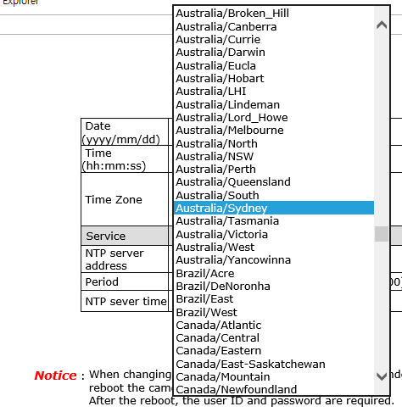
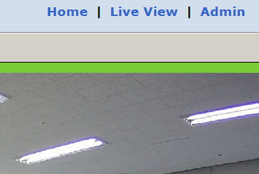

Cf 1: TimeZone - Australia/Sydney (All contents below should be entered.)
http://192.168.0.104/cgi-bin/admin/nsssetntpconf.cgi?
NssTimeZoneChange=1&
NssTimeZone=Australia/Sydney&
NssYear=2021&
NssMonth=12&
NssDay=14&
NssHour=8&
NssMinute=59&
NssSecond=10&
FwCgiVer=0x0001

http://192.168.0.48/cgi-bin/admin/nsssetntpconf.cgi?NssTimeZoneChange=1&NssTimeZone=Australia/Sydney&NssYear=2021&NssMonth=12&NssDay=14&NssHour=8&NssMinute=59&NssSecond=10&FwCgiVer=0x0001
CGI COMMAND WEB INPUT IMAGE
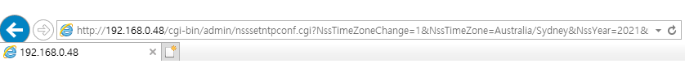

Cf 2: TimeZone - Australia/Melbourne (All contents below should be entered.)
http://192.168.0.104/cgi-bin/admin/nsssetntpconf.cgi?
NssTimeZoneChange=1&
NssTimeZone=Australia/Melbourne&
NssYear=2021&
NssMonth=12&
NssDay=14&
NssHour=8&
NssMinute=59&
NssSecond=10&
FwCgiVer=0x0001

http://192.168.0.48/cgi-bin/admin/nsssetntpconf.cgi?NssTimeZoneChange=1&NssTimeZone=Australia/Melbourne&NssYear=2021&NssMonth=12&NssDay=14&NssHour=8&NssMinute=59&NssSecond=10&FwCgiVer=0x0001

CGI COMMAND WEB INPUT IMAGE

NTP time sync command
[IP address]/cgi-bin/admin/nsssyncntpserver.cgi?SvrAddr=’pool.ntp.org’&FwMkChg=YES&CgiVer=0x0001
http://192.168.0.53/cgi-bin/admin/nsssyncntpserver.cgi?SvrAddr='pool.ntp.org'&FwMkChg=YES&CgiVer=0x0001

Network Setting for Static or DHCP

STATIC :
[IP Address]/
cgi-bin/admin/net_setnetworkv2.cgi?Eth0Ip=192.168.216.251&Eth0NetMask=255.255.0.0&Gateway=
192.168.0.1&Dns1=203.248.252.2&Dns2=164.124.101.2&Ipv6Enable=no&Eth0LinkLocal=fe80%3A%3A230%3A6fff%3Afe10%3A2b23%2F64&LanEthMode=static&SaveCfg=YES&FwRmChg=YES&CgiVer=0x0001&ChkNetChg=YES

DHCP :
[IP Address]/
cgi-bin/admin/net_setnetworkv2.cgi?Dns1=203.248.252.2&Dns2=164.124.101.2&LanEthMode=dhcp&SaveCfg=
YES&FwRmChg=YES&CgiVer=0x0001&ChkNetChg=YES

